 | 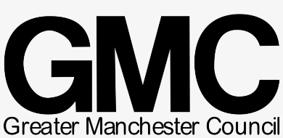

Supporting Individuals in Need across Greater Manchester
Community response hubs have been created across Greater Manchester to support individuals in crisis, please contact your local hub for support and advise about food, prescriptions, fuel top up payments, bills, finance and combating loneliness.

- Manchester City Council 0800 234 6123 Open 8.30-5.30 mon-sat
- Salford 0800 952 1000 - weekdays between 8.30am and 6pm.
- Trafford Monday to Friday 8.30am to 5.30pm
- Oldham 0161 770 7007 9am-5pm on weekdays and 11am to 2pm on weekends
- Rochdale 01706 923685 | 0300 303 8875
- Stockport 0161 217 6046 - Mon to Fri from 9am to 5pm Saturdays from 10am to 4pm.
- Tameside 0161 342 8355
- Bury 0161 253 5353
- Wigan 01942 489018

Keep Safe and Well

